North Ayrshire Council

Application for Opening Permit

Roads (Scotland) Act 1984 – Section 56

Public liability insurance of no less than £5m must be held by the applicant and a copy of the policy document must be provided before the permit will be issued.

Applicant Details

Company Name: Click or tap here to enter text.
Contact Name: Click or tap here to enter text.
Address: Click or tap here to enter text.
Town: Click or tap here to enter text.
Postcode: Click or tap here to enter text.
Phone: Click or tap here to enter text.
Email: Click or tap here to enter text.

Work Details

Location of works: Click or tap here to enter text.
Address: Click or tap here to enter text.
Town: Click or tap here to enter text.
Postcode: Click or tap here to enter text.

Type of Road Opening Permit Required:
Vehicle Access Crossing ☐ Other Excavation ☐
Description of undertakings: Click or tap here to enter text.

Start Date: Click or tap to enter a date. End Date: Click or tap to enter a date.
Copy of Public Liability Insurance and relevant plans submitted? ☐Yes ☐ No
Copy of relevant qualifications submitted? ☐ Yes ☐ No

Finance Details

As per Applicant ☐ Yes ☐No (Invoice details to be supplied below)
Company Name: Click or tap here to enter text.
Contact Name: Click or tap here to enter text.
Address: Click or tap here to enter text.
Town: Click or tap here to enter text.
Postcode: Click or tap here to enter text.
Email: Click or tap here to enter text.

Purchase Order Number: Click or tap here to enter text.

Failure to provide payment details will delay the approval of your application and works.

Notes for applicants

- This permit does not carry with it any rights to interfere with any apparatus in or above the street or pavement, and consequently before the commencement of work, the position of any such apparatus should be determined by contacting Roadworks Scotland
- No openings shall be permitted on bridges nor shall any tunnelling be allowed unless special detailed application is made and approved.
- Within 3 months of the expiry of the maintenance period North Ayrshire Council (Roads) where necessary, make a permanent repair at the applicants’ expense.
- Please note that Road Opening Permits will not be processed by the Roads Service unless a copy of your qualifications for working on the public road (i.e. HAUC Supervisors and Operatives Permits or SQA/CITB Highway Maintenance Qualifications) and current public liability insurance policy are returned with the completed permit application.

Declaration

I/we undertake to:
- Comply with the condition and specification made by North Ayrshire Council.
- Relieve North Ayrshire Council of all liability for any loss, injury or damage due to my / our operations.
- Maintain the reinstatement in good condition during the maintenance period of 12 months from the date of the works as notified to the office issuing the permit.

Signed: Click or tap here to enter text. Date: Click or tap to enter a date.
On behalf of: Click or tap here to enter text.
Completed applications should be emailed to roadspermits@north-ayrshire.gov.uk For information on how we process your data, please refer to North Ayrshire Council Privacy page.

For assistance and general enquiries, please call the freephone call centre on 01294 310000 and ask to speak to a member of the Network Team.

Office Approval

Approved ☐ Yes ☐ No
Approved By Click or tap here to enter text. DateClick or tap to enter a date.
This is to certify that permission has been granted in connection with the above application subject to compliance with the attached conditions. This certificate must be shown if requested by a Police Officer of North Ayrshire Council.

This section is to be returned to the North Ayrshire Council (Roads) following completion of the work

Permit Number Click or tap here to enter text.
Applicants Name Click or tap here to enter text.
Permit Address Click or tap here to enter text.

Dear Sir, the temporary restoration of the road opened by me has been completed in accordance with the conditions and specifications stipulated. I request that Commercial Services (Roads) carry out the permanent reinstatement at my expense/I have completed the permanent reinstatement.

Signed Click or tap here to enter text.
Date Click or tap to enter a date.

Guidance notes and specification for road openings

The applicant should contact all Statutory Undertakers for details of their apparatus before any excavations are carried out. Guidance should also be sought from North Ayrshire Council on the location of street lighting or traffic signal ducts.
All works must comply with the requirements of the Specification for the Reinstatement of Openings in Roads (October 2003 Edition), published by the Scottish Executive.
The reinstatement shall be to the compacted thicknesses as follows with each layer being fully compacted. Where widths do not allow a twin drum or vibrating roller onto the material, it should be compacted by means of a vibrotamper.
All permanent reinstatements will be subject to a twelve-month maintenance period, any defects which occur within the maintenance period shall be rectified at the applicant’s expense.

Flexible carriageway (permanent reinstatement)
Table 1
LAYER | BUS ROUTES /  MAIN ROADS | OTHER ROADS | MATERIALS TO BE USED
Surface Course (a) | 40mm | 40mm | Rolled Asphalt (CL 910) or Asphalt Concrete
Combined Binder Course and Base Course | 245mm | 150mm | Dense Macadam (CL 903)
Sub-base and Backfill | 500mm minimum | 500mm minimum | Type 1 granular sub-base compacted in 100mm layers (CL803)

Footway or shared surface roads (permanent reinstatement)
Table 2
LAYER | BITUMINOUS SURFACE | SLABS OR BLOCK PAVING (c) | GRANOLITHIC
Surface Course (b) | 30mm Rolled Asphalt (CL 910) | Relay identical slabs/blocks on 50mm sharp sand  (Appendix 11/1) | 40mm of Granolithic Concrete (CL 1704)
Binder Course | 50mm Dense Macadam (CL 906) | 175mm of Type 1 Granular Fill (CL 803) | 75mm 25/37.5mm Concrete (CL 1704)
Base Course and Sub-base | 150mm of Type 1 Granular Fill (CL 803) | 175mm of Type 1 Granular Fill (CL 803) | 150mm of Type 1 Granular Fill (CL 803)
Backfill | Varying thicknesses of Type 1 Granular Fill (CL 803) | Varying thicknesses of Type 1 Granular Fill (CL 803) | Varying thicknesses of Type 1 Granular Fill (CL 803)

- The surface course material shall match the surrounding surface course. Contact the Council for further guidance if required.
- Prior to compaction 10mm limestone chippings shall be applied at a rate of 1kg/m2 to the surface course.
- On shared surface carriageways the block paving reinstatement specification shall apply.

Footway Access Crossings
Table 3
TYPE | SUB-BASE | BINDER COURSE | SURFACE COURSE
Flexible Surfacing | 225mm Granular Sub-base Type 1 (CI 803) | 30mm Close Graded Asphalt Concrete  (CI.912 – BS EN 13108-1:2016  Table 4, Column 4  AC 10 Close Surf | 30mm Hot Rolled Asphalt  (CI 910 – BS EN 13108-4:2016 Table 4 Column 4)  HRA 15/10 F surf 40/60 recipe  Prior to compaction 10mm limestone chippings shall be applied to the surface at a normal rate of 1kg/sq.m

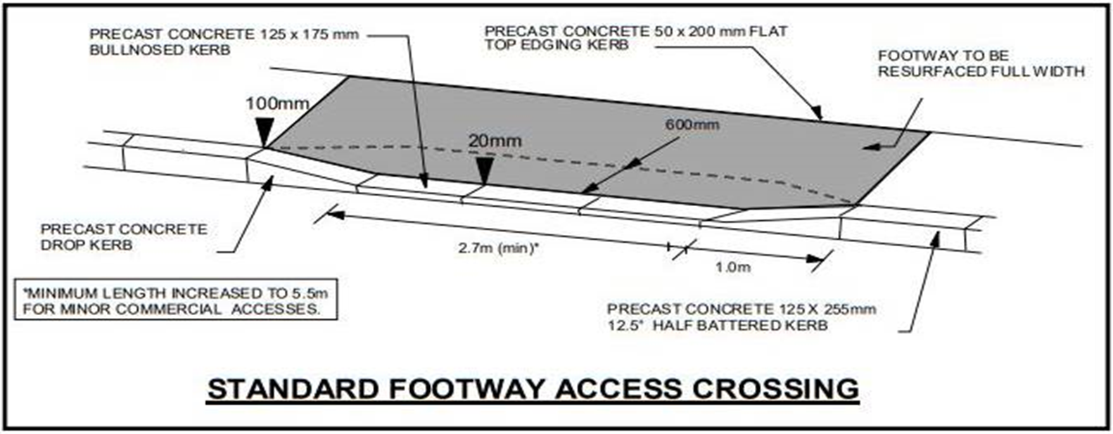
- All references in the table above are to the Specification for Highway Works
- All access crossings will be formed by a Contractor approved and supervised by a representative of the Roads Service
- The Contractor must be covered by Public Liability Insurance
- The Contractor must obtain a Section 56 Road Opening Permit prior to undertaking works
- Additional costs may be incurred if any deviation is required from the standard layout
- Any access crossing formed without complying with the Specification and Drawings will be treated as a contravention of Section 56 of the Roads Scotland Act 1984 and appropriate action will be taken.

Notes: The Roads (Scotland) Act 1984 Section 56 states:

- No works shall be executed in, or excavation made under, a public road except with the Roads Authority’s consent in writing and in accordance with any reasonable conditions, which they think fit to attach to the consent.
Persons contravening this section shall be guilty of an offence and shall be liable to a fine not exceeding £200 (December 1985).
- A person shall, as soon as reasonably practicable make good any damage to the road occasioned by the works or excavation and shall immediately thereafter give notice to the authority that the damage is made good; and until twelve months have elapsed from the authority certifying that the damage has been made good to their satisfaction the person shall maintain so much of the road as is made good.
- Works executed, or an excavation made, in contravention of 1 above, may be removed or filled in by the Roads Authority who may recover such expenses as are reasonably incurred in so doing.

