Property Enquiry Service

To: North Ayrshire Council
Property Enquiry Service
Cunninghame House
IRVINE
KA12 8EE

Contact: Pamela Tannock/Tom Gilmour
Phone: (01294) 324772 OR (01294) 324752
Email: propertyenquiries@north-ayrshire.gov.uk

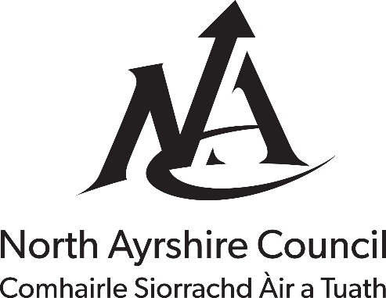

Property Enquiry Certificate Fee: £72.00
(Property enquiry reply includes information from Planning, Environmental Health, Housing, Building Standards and Roads)

Property details
Property detail | Enter your response
Type of premises (for example: house, flat, shop, factory, hotel) | Click or tap here to enter type of premises.
Property name and number | Click or tap here to enter property name and number.
Location of property within building (for example: ground floor, first floor) | Click or tap here to enter location in building.
Property address | Click or tap here to enter property address.
Postcode | Click or tap here to enter postcode.
Please enclose a plan for rural properties or properties on the Isle of Arran

Solicitor details
Solicitor detail | Enter your response
Date | Click or tap here to enter date.
Reference | Click or tap here to enter reference.
Name | Click or tap here to enter name of solicitor.
Address (including postcode) | Click or tap here to enter address including postcode.
Phone number | Click or tap here to enter phone number.
Email address | Click or tap here to enter email address.

