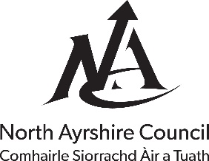
The Licensing (Scotland) Act 2005

Application for Food Hygiene Certificate under Section 50 of the above Act
Form C

For Official Use Only
Date of Receipt of Application: Click or tap to enter a date.
Reference Number: Click or tap here to enter text.
Date of Payment of Fee: Click or tap to enter a date.
Cheque, Cash, Monthly Order: Click or tap here to enter text.
Date of Issue of Certificate: Click or tap to enter a date.
Application is hereby made by (a): Click or tap here to enter text.
To: Senior Manager, Protective Services, North Ayrshire Council, Cunninghame House, Friars Croft, Irvine, KA12 8EE (Email: economicgrowthsupport@north-ayrshire.gov.uk)
For a Food Hygiene Certificate (b) as to the suitability of the premises at (c): Click or tap here to enter text.
For which (Grant) (Provisional Grant) of a new Premises Licence is being sought.
Application fee of £137.81 is enclosed.
Signature of Applicant/Agent: Click or tap here to enter text.
Address (d): Click or tap here to enter text.
Date: Click or tap to enter a date.
(Notes – See Over)

Notes
- Name, designation and address of applicant.
- In respect of a Food Hygiene Certificate it is understood that plans giving full information relating to construction, layout, drainage, ventilation, lighting and water supply and also regarding provision of sanitary and washing facilities will be lodged with the principal application for licence with the Clerk to the Board.
- Address of premises.
- Address to which all correspondence will be sent.

