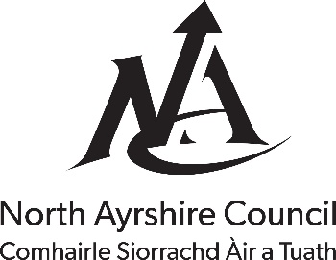
The Licensing (Scotland) Act 2005

Application for Building Standards Certificate under Section 50

For Office Use Only
Reference number: Click or tap here to enter text.
Amount received: Click or tap here to enter text.
Payment type: Click or tap here to enter text.
Date received: Click or tap to enter a date.
- Name and Address of Applicant and Agent (if appropriate): Click or tap here to enter text.
- Address of Premises: Click or tap here to enter text.
- Provide the following information:
- (a) Date and reference of Building Warrant for the construction of the premises: Click or tap here to enter text.
(b) Date and reference of Acceptance of Certificate of Completion: Click or tap here to enter text.
(c) Or if no Building Warrant for the construction of the premises is required, give reasons: Click or tap here to enter text.
- (a) Date and reference of Building Warrant for the change of use of the premises: Click or tap here to enter text.
(b) Or if no such Building Warrant is required, give reasons: Click or tap here to enter text.
- Plans of Premises and a Draft Operating Plan: Click or tap here to enter text.
I/We hereby certify that the plans accompanying this application are an exact copy of the plans I/we intend to lodge with North Ayrshire Licensing Board.
Signature of Applicant/Agent: Click or tap here to enter text.
Date: Click or tap to enter a date.

Address to which application should be submitted together with 1 set of plans, a copy of the draft operating plan (if available) and a fee of £137.81:
North Ayrshire Council
Building Standards
Cunninghame House
Irvine
KA12 8EE
Email: economicgrowthsupport@north-ayrshire.gov.uk
Telephone: (01294) 324348

