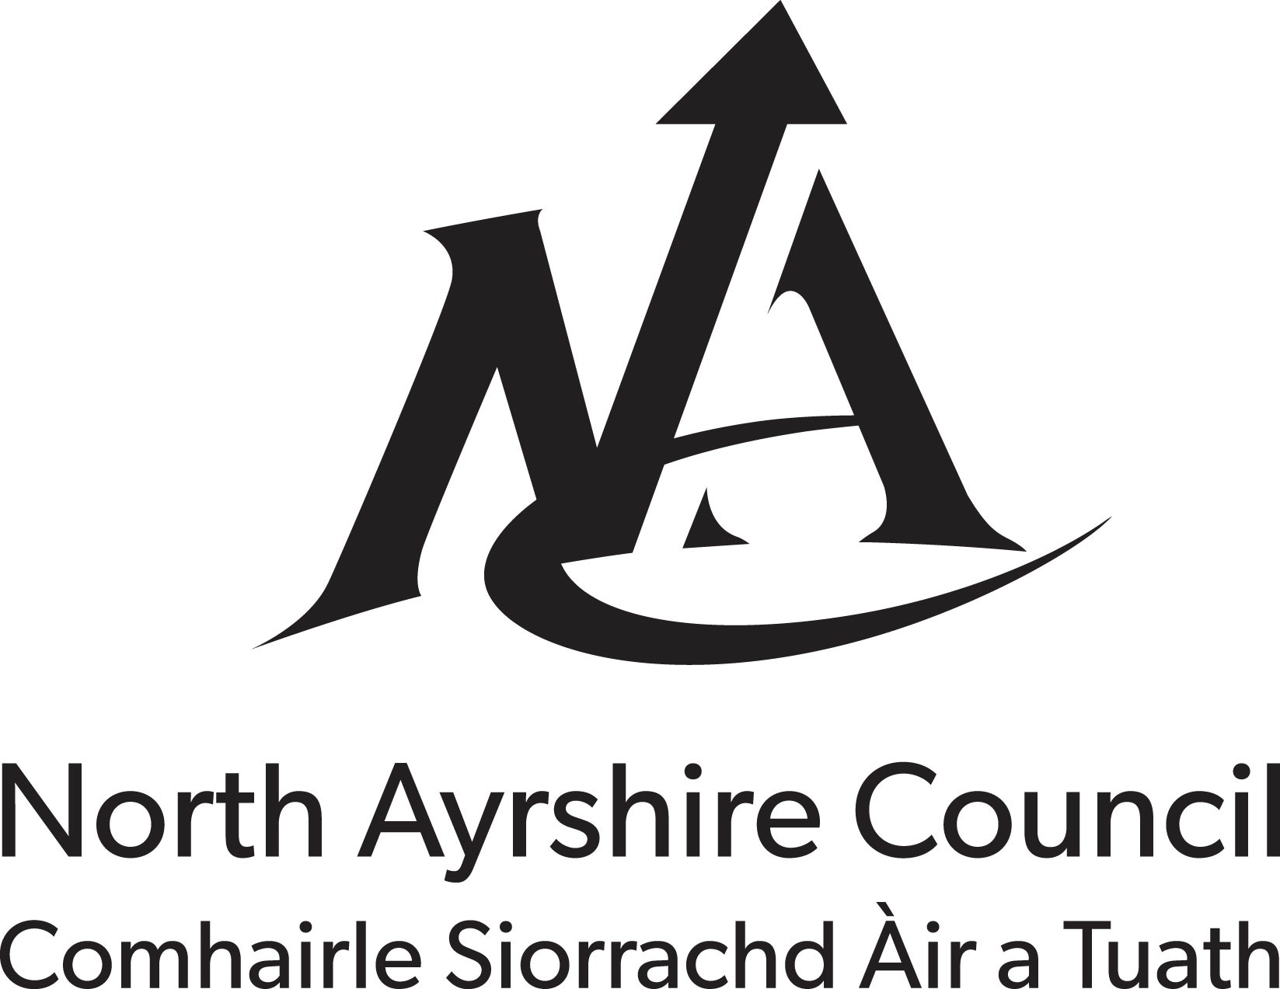

APPLICATION FOR THE REGISTRATION OF A FOOD BUSINESS ESTABLISHMENT
(Regulation (EC) No. 852/2004 on the Hygiene of Foodstuffs, Article 6(2))

This form should be completed by Food Business Operators in respect of new Food Business Establishments and submitted to the relevant food authority 28 days before commencing food operations. On the basis of the activities carried out, certain Food Business Establishments are required to be Approved rather than Registered. If you are unsure whether any aspect of your food operations would require your establishment to be approved, please contact North Ayrshire Council for guidance.

- Address of establishment (or address at which moveable establishment is kept)

Post Code

- Name of Food Business (Trading Name) _Telephone no.

Full Name of Food Business Operator

- Address of Food Business Operator

Post Code Telephone No. E-mail
- Type of Food Business (Please tick ALL the boxes that apply): 6. Type of Business:

Farm Shop | □ Staff restaurant/canteen/kitchen | □ Sole Trader | □
Food manufacturing/processing | □ Catering | □ Partnership | □
Packer | □ Hospital/residential home/school | □ Limited Company | □
Importer  Wholesale/cash and carry | - Hotel/pub/guest house  - Private house used for a food business | □ Other (please give details)  □ | □
Distribution/warehousing Retailer | - Moveable establishment e.g. ice cream van  - Market stall | □  □
Restaurant/café/snack bar Market | - Food Broker  - Takeaway | □  □ (If Limited Company, please
Seasonal Slaughterer | □ Other (please give details): | complete 7. below)

Limited Company Name Company No Registered Office Address

Post Code

- If this is a New Business? Yes / No If Yes, please specify the date you intend to open

- If this is a Seasonal Business? Yes / No If Yes please specify the period during which you intend to be open each year

Signature of Food Business Operator
AFTER THIS FORM HAS BEEN SUBMITTED, FOOD BUSINESS OPERATOR MUST NOTIFY ANY CHANGES TO THE ACTIVITIES STATED ABOVE TO NORTH AYRSHIRE COUNCIL AND SHOULD DO SO WITHIN 28 DAYS OF THE CHANGE(S) HAPPENING.
Date_______________________________________________________________

Name (BLOCK CAPITALS)
Please return to: North Ayrshire Council,
Environmental Health, Cunninghame House, Irvine, KA12 8EE
Email: Environmentalhealth@north-ayrshire.gov.uk

PRIVACY NOTICE

What we need

North Ayrshire Council and Food Standards Scotland (FSS) are Joint Data Controllers of the personal information you provide to us on this form. The information we collect about you includes name, postal address, email address and telephone number.

Why we need it

- As Joint Data Controllers, we need to collect this information for the purposes of Food Law Enforcement.
- Regulation (EC) No 882/2004 on Official Controls performed to ensure the verification of compliance with Food Law, requires that North Ayrshire Council and FSS coordinate effectively in the field of Environmental and Health protection, carrying out their activities with a high level of transparency, making relevant information available to the public as soon as possible.
- Each Local Authority is required to maintain an up to date list of registered Food Business Establishments in its area and divulge this information for the purposes of ensuring public health and the effective enforcement of Food Law.
- The Food (Scotland) Act 2015, enables FSS to set performance standards, report on enforcement action by others and require relevant information from North Ayrshire Council
- The Official Feed and Food Controls (Scotland) Regulations 2009, allows the exchange and provision of information by FSS and North Ayrshire Council for the execution and enforcement of relevant Food Law, and makes provision for North Ayrshire Council to provide FSS with Food Business information.
- North Ayrshire Council and FSS are required to fulfil the statutory obligations required by Article 113 of Regulation (EC) No 2017/625, which places a requirement on Local Authorities and FSS to provide the information specified in that Article and to report to the European Commission.
- FSS maintains a national database that can be accessed by both Food Standards Scotland and the Local Authority to which the information pertains. The reporting toolset allows information to be strategically analysed, allowing both organisations to adhere to the principles of the Scottish Regulators’ Strategic Code of Practice.
- We will only collect the data that we need as required by the above regulations and legislations, and not collect any personal information from you that we do not need.

What we do with it
The information on this form will be retained by North Ayrshire Council and FSS for the duration of your business registration. Additionally if your business closes, or your registration details are otherwise amended then this information will continue to be retained for a maximum of six years following notification of the closure or the amendment of your registration details.

The information collected on your business relating to Food Law enforcement activity will be retained by North Ayrshire Council for a maximum of six years for Freedom of Information purposes. Food Standards Scotland collects food business information from North Ayrshire Council on a regular basis for the purposes of Food Law Enforcement. The same information will be retained by FSS for a maximum of 6 years, also for Freedom of Information purposes and the monitoring of enforcement action by Local Authorities.

FSS have put in place appropriate and adequate technical and organisational measures to protect your personal information. FSS data is located within the European Union, on cloud based services procured through the government framework agreements, and assessed against the national cyber security centre cloud security principles.

Details of how North Ayrshire Council will handle personal data and how to contact our Data Protection Officer can be found in our corporate privacy policy at https://www.north-ayrshire.gov.uk/privacy-policy.aspx

We want to assure you that no third parties have access to your personal information unless the Law allows them to do so.

What we may also be required to do with it

The information may be shared with other Regulators in line with the principles of the Scottish Regulators Strategic Code of Practice for compliance and risk mitigation purposes. This is limited to circumstances where the law allows such sharing of information by regulators with common interests or activities and will not include personal information.

What are your rights?

You have a right to see the information we hold on you by making a request in writing to the email addresses below. If at any point you believe the information we process on you is incorrect you can request to have it corrected. If you wish to raise a complaint on how we have handled your information, you can contact our Data Protection Officers who will investigate the matter. If you are not satisfied with our response or believe we are not processing your information in accordance with the law you can complain to the Information Commissioner’s Office (ICO).

If you need any further information please contact North Ayrshire Council's Data Protection Officer at dataprotectionofficer@north-ayrshire.gov.uk. Or Food Standards Scotland’s Data Protection Officer at: dataprotection@fss.scot.

