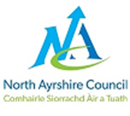

CONFIRMATION OF SALARY POINT

This form is to be used to confirm the salary point for teachers who are joining North Ayrshire Council’s Supply Register. It is the responsibility of the teacher to issue this form to their previous employer and submit the fully completed form with their supply paperwork to one of the local offices as mentioned on the email.

TEACHER’S DETAILS

Teacher’s Name |  | National Insurance No.
GTC No. |  | Salary Point as of 01.08.21

AUTHORISED BY

Name
Council
Signature
Date

Should this be submitted after the supply pack has been received then the processing of the new salary will become effective on the next pay period. If this is the case please return to resourcinghr@north-ayrshire.gov.uk

