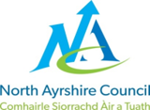

North Ayrshire Council

# Application for Opening Permit

## Roads (Scotland) Act 1984 – Section 56

Public liability insurance of no less than £5m must be held by the applicant and a copy of the policy document must be provided before the permit will be issued.

## Applicant Details

Company Name: Click or tap here to enter text.

Contact Name: Click or tap here to enter text.

Address: Click or tap here to enter text.

Town: Click or tap here to enter text.

Postcode: Click or tap here to enter text.

Phone: Click or tap here to enter text.

Email: Click or tap here to enter text.

## Contractor Details

Company Name: Click or tap here to enter text.

Contact Name: Click or tap here to enter text.

Address: Click or tap here to enter text.

Town: Click or tap here to enter text.

Postcode: Click or tap here to enter text.

Phone: Click or tap here to enter text.

Email: Click or tap here to enter text.

## Work Details

Location of Works: Click or tap here to enter text.

Town: Click or tap here to enter text.

Postcode: Click or tap here to enter text.

Easting Start: Click or tap here to enter text.

Northing Start: Click or tap here to enter text.

Easting End: Click or tap here to enter text.

Northing End: Click or tap here to enter text.

### Type of Road Opening Permit Required

Vehicle Access Crossing (Max 1 week duration) Other Excavation

Description of Undertakings: Click or tap here to enter text.

Work Technique: Choose an item.

Traffic Management: Choose an item.

Duration: 1 to 3 workings days 4 to 10 working days 10> working days   
Processing: (5 working days’ notice) (10 working days’ notice) (4 weeks notice)

Start Date & Time: Click or tap to enter a date.

End Date & Time: Click or tap to enter a date.

Copy of Public Liability Insurance and relevant plans submitted? Yes  No

Copy of relevant qualifications submitted?  Yes  No

## Finance Details

As per Applicant  Yes No (Invoice details to be supplied below)

Company Name: Click or tap here to enter text.

Contact Name: Click or tap here to enter text.

Address: Click or tap here to enter text.

Town: Click or tap here to enter text.

Postcode: Click or tap here to enter text.

Email: Click or tap here to enter text.

Purchase Order Number: Click or tap here to enter text.

Failure to provide payment details will delay the approval of your application and works.

## Notes For Applicants

1. This permit does not carry with it any rights to interfere with any apparatus in or above the street or pavement.
2. Permits are valid for a maximum duration of one week, thereafter an additional week fee will be applied at 50% the basic permit charge per week.
3. All applicants are responsible for contacting North Ayrshire Council to confirm the commencement of your works within 2 hours of starting. Additionally, you must notify the Council again within this timeframe once the works are complete.
4. Where an early start is requested to commence works ahead of the specified processing period an additional permit charge will be applied.
5. Where there is a delay caused to the completion of works that require the initial In Progress works to be extended, an extension fee will be charged per week at 50% the basic permit charge. The extension period shall not exceed the duration of the initial application.
6. Where an amendment to an application is required, a fee will be charged at 50% the basic permit charge.
7. Please note that under Section 131 of the NRSWA, the Roads Authority may undertake Investigatory works to check whether undertakers are complying with their duties with respect to adequately guarding and lighting their works and reinstating roads. Should these investigations reveal that the works do not comply, then the Roads Authority may charge for these inspections and any remedial works undertaken.
8. No openings shall be permitted on bridges, nor shall any tunnelling be allowed unless special detailed application is made and approved.
9. Failure to provide a copy of your qualifications for working on the public road (i.e. SWQR) Supervisors and Operatives qualification and public liability insurance policy will result in your application being declined.

## Standard Conditions

1. All works must comply with the current edition of the Specification for the Reinstatement of Openings in Roads, published by the Scottish Executive. Any defects which occur within the guarantee period shall be rectified at the applicant’s expense.
2. It is your duty to liaise with Statutory Undertakers as appropriate. You must secure information on the location of their apparatus and how your works may affect that apparatus. You must do this by telephoning "Dial before you dig" call centre (08000 231 251) where your enquiry details will be passed on to the various Undertakers who, in turn, will furnish you with the necessary information.
3. Permission under Section 56 of the Act does not extend to other ancillary activities such as depositing a skip, occupying the road with building materials, erecting a scaffold, erecting temporary traffic lights or Stop/Go boards etc. Further advice and permissions must be sought from North Ayrshire Council.
4. Under the terms of Section 124 of NRSWA 1991, the applicant must ensure that all excavations or obstructions in the road are adequately guarded and lit and that such traffic signs are placed, maintained and where necessary operated, as are reasonably required for the guidance or direction of road users in accordance with Section 120 of the Roads (Scotland) Act 1984 (duty to have regard to the needs of people with a disability).  Failure to comply with Section 124 of NRSWA 1991 is an offence and is liable on summary conviction to a fine not exceeding level 3 (£1,000) on the standard scale.  If the applicant fails to comply with these requirements, the Roads Authority may take any steps as necessary and recover reasonable costs from the applicant. Legal requirements in relation to Safety, Signing, Lighting and Guarding are contained in "Safety at Street Works and Road Works - A Code of Practice".
5. The applicant shall indemnify North Ayrshire Council from and against all actions, claims, demands, costs, charges, damages, losses and expenses of whatever kind or nature which may be brought or made against them or incurred by them in respect of the negligence, omission or default of the holder of the consent or those for whom the holder is responsible arising in respect of any operation authorised by his/her consent unless due to the negligence or other breach of legal duty on the part of the Roads Authority or of any person for whom the Roads Authority is responsible.

### Footway Access Crossings

Where a domestic vehicle crossing a footway, footpath or cycletrack, including specified pedestrian areas or precincts is to be constructed, the structure and reinstatement shall be to the thicknesses as follows with each layer being fully compacted. Where widths do not allow a twin drum or vibrating roller onto the material, it should be compacted by means of a vibrotamper.

| Type | Sub-Base | Binder course | Surface course |
| --- | --- | --- | --- |
| Flexible Surfacing | 225mm Granular Sub-base Type 1 (CI 803) | 30mm Close Graded Asphalt Concrete  (CI.912 – BS EN 13108-1:2016  Table 4, Column 4  AC 10 Close Surf | 30mm Hot Rolled Asphalt  (CI 910 – BS EN 13108-4:2016 Table 4 Column 4)  HRA 15/10 F surf 40/60 recipe  Prior to compaction  6-10mm limestone chippings shall be applied to the surface at a normal rate of 1kg/sq.m |

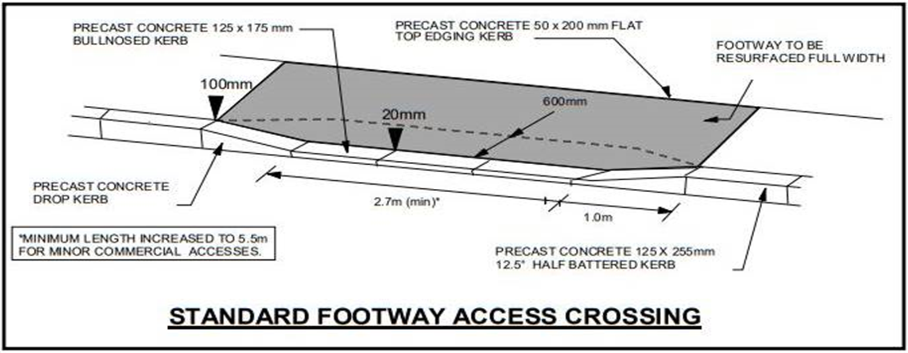

## Declaration

I/we undertake to:

* Comply with the conditions and specification made by North Ayrshire Council.
* Relieve North Ayrshire Council of all liability for any loss, injury, or damage due to my / our operations.
* Maintain the reinstatement in good condition during the applicable guarantee period (SROR).

Signed: Click or tap here to enter text.

Date: Click or tap to enter a date.

On behalf of: Click or tap here to enter text.

Completed applications should be emailed to [roadspermits@north-ayrshire.gov.uk](mailto:roadspermits@north-ayrshire.gov.uk) For information on how we process your data, please refer to [North Ayrshire Council Privacy page.](https://www.north-ayrshire.gov.uk/privacy-policy)

For assistance and general enquiries, please call the freephone call centre on 01294 310000 and ask to speak to a member of the Network Team.

## Office Approval

Approved:  Yes  No

Approved By: Click or tap here to enter text.

Date: Click or tap to enter a date.

Permit Number: Click or tap here to enter text.

This is to certify that permission has been granted in connection with the above application subject to compliance with the attached conditions. This certificate must be shown if requested by a Police Officer of North Ayrshire Council.