# North Ayrshire Council Amenity Licence Application

## Roads (Scotland) Act 1984 – section 90

Application for a licence to erect amenities (such as display banners, hanging baskets, seasonal decorations/lights etc) over a public road, footway or verge.

**Important:** Please complete this form in full and provide all requested documentation. Failure to do so may result in delays or refusal.

## Details of Applicant

Name: Click or tap here to enter name.

Address: Click or tap here to enter address.

Email Address: Click or tap here to enter email address.

Telephone Number: Click or tap here to enter telephone number.

## Details of Contractor/Organisation erecting displays etc (if different from above)

Name: Click or tap here to enter name.

Address: Click or tap here to enter name.

Email Address: Click or tap here to enter name.

Telephone Number: Click or tap here to enter name.

## Name of responsible person to be contacted in the event of a fault, emergency etc.

Name: Click or tap here to enter name.

24 Hour Telephone Number: Click or tap here to enter telephone number.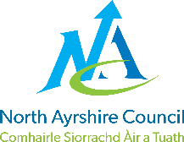



## Details of Display

Please enter details below of the type of amenity being requested (such as seasonal decoration, promotional banners, hanging baskets etc)

Click or tap here to enter details.

Please detail below the precise location(s) of the proposed amenity. Please include building name/address and street name(s)

Click or tap here to enter location(s).

Proposed date of amenity display set-up/installation: Click or tap to enter a date.

Proposed date of removal: Click or tap to enter a date.

Does this application involve attaching anything to lighting columns (lamp posts)? Yes  No

If you answered Yes above, please list here the relevant lighting column numbers (you should find numbers marked on all lighting columns): Click or tap here to enter text.

Have supports been structurally inspected? Yes  No

Is previous inspection still valid? If yes, please supply copy of Inspection Certificate. Yes  No

Can you provide evidence of display features being electrically tested? Yes  No

Are displays using lighting supply network? Yes  No

Wattage/consumption details provided to allow electrical load calculations? Yes  No

Can you provide evidence of electrical network having been electrically tested? Yes  No 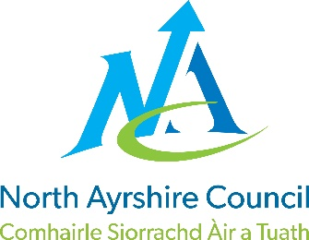

Please include the following documents with your application:

* A copy of relevant location plan(s)
* Evidence of public liability insurance
* Detailed technical specification, and installation details, of any proposed attachments from supplier.
* A copy of energy agreement if required (please see below for more details on this)
* Structural Inspection Certificate (if still valid)
* Wattage/consumption details

**Please remember if you do not include these documents, it may cause delays or refusal of the application.**

**Energy Agreements**

If your amenity requires an electricity supply, the loading/wattage details provided by the manufacturer or supplier and required timeframe should be passed to Scottish Power who can be contacted on 0800 074 0052 or visit the [Scottish Power website](http://www.scottishpower.co.uk/). They will confirm your connection to their network, power consumption and cost/agreement. Once calculated, they will ask you to identify your preferred supplier (e.g. Scottish Power, Scottish Gas, N-Power etc). You will be required to enter an energy agreement with your supplier for the costs of the energy used.

**Amenity Display Conditions**

Please tick this box to confirm that you agree to the Amenity Display Conditions, which can be accessed by [visiting our website](https://www.north-ayrshire.gov.uk/roads) and selecting “Road Maintenance and Permits.”

Please email the completed form and all required documents to [roadspermits@north-ayrshire.gov.uk](mailto:roadspermits@north-ayrshire.gov.uk) or send by post to **North Ayrshire Council, Roads Permits, 3rd Floor East, Cunninghame House, Irvine, KA12 8EE**.

If you have any queries, please telephone our **freephone** call centre on **01294 310000.**

**This section to be completed by North Ayrshire Council staff processing this application.**

Have all required details and documents been provided? Yes  No

Has this application been approved? Yes  No

Licence Number: Click or tap here to enter licence number.

Approved By: Click or tap here to enter name.

Approval Date: Click or tap to enter a date.

Comments: Click or tap here to enter comments.****