North Ayrshire Council

Commercial Services (Roads)
Application for a Temporary Road Traffic Regulation Order (TTRO)

Applicants’ details

Contact name:
Organisation:
Address:
Postcode:
Telephone number:
Email:
Purchase Order number (required):
Project code/job number:
Invoice address, contact name and telephone number (if different from above):

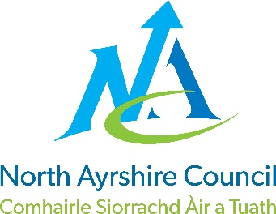

Activity/Works details

Reason for restriction (mains renewal/resurfacing etc):
SRWR number:

Are these emergency works? ☐Yes ☐ No
Do works require permanent traffic signals to be switched off? ☐Yes ☐No
Is there a bus stop or stops within the works area? ☐Yes☐No
Bus stop number(s)

Location details

Road name and number (if known):
Town or village
Section to be restricted (between junctions of…) :

Proposed restriction

Type of restriction required (road closure, waiting restriction etc):
For road closure please indicate where advanced notification boards will be situated and when they will be installed (Must be at least 7 days before closure).
A4 plan attached:

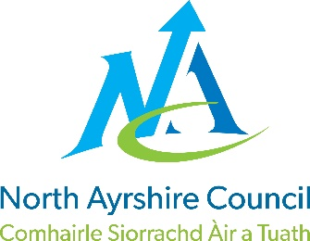

Current restrictions

Type of restrictions currently in place, such as no waiting (double yellow lines) or one-way system etc:

Suggested alternative route

Suggested diversion route (include road names/numbers and whether the same for both directions of travel):
A4 diversion plan attached | ☐Yes ☐No

Dates restriction required

What date and time will the restriction be implemented?
What date and time will the restriction be removed?
Is the restriction in place 24 hours a day?

Allowable access

Note: you must state clearly what access is available through the restriction whilst in force (this must include pedestrian, frontage and emergency access arrangements). Failure to do so may invalidate the Order and constitute an illegal obstruction of the carriageway.

What access will be made available during the restriction?

Works management information

Note: Out of hours contact number must be a number that is reachable, for instance, not an unmanned call centre.
Working hours site contact:
Working hours telephone number:
Out of hours site contact:
Out of hours telephone number:

Additional information/declaration

Any additional information:

Applicant’s signature:
Date of application:

Please return your completed application, location and diversion plans to:

Address: Commercial Services (Roads)
3rd floor east
Cunninghame House
Irvine
KA12 8EE

Email: roadspermits@north-ayrshire.gov.uk
For assistance and general enquiries, please call the freephone call centre on 01294 310000 and ask to speak to a member of the Network Team.

