North Ayrshire Council

Roads (Scotland) Act 1984 – section 90

Application for a licence to erect amenities (such as display banners, hanging baskets, seasonal decorations/lights etc) over a public road, footway or verge.

Important: Please complete this form in full and provide all requested documentation. Failure to do so may result in delays or refusal.

Details of Applicant
Name
Address
Email Address
Telephone Number

Details of Contractor/Organisation erecting displays etc (if different from above)
Name
Address
Email Address
Telephone Number

Name of responsible person to be contacted in the event of a fault, emergency etc.
Name
24 Hour Telephone Number
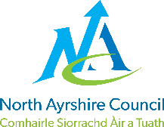

Please enter details below of the type of amenity being requested (such as seasonal decoration, promotional banners, hanging baskets etc)
Please detail below the precise location(s) of the proposed amenity. Please include building name/address and street name(s)

Proposed date of amenity set up/installation (dd/mm/yyyy)
Proposed date of removal
(dd/mm/yyyy)

Does this application involve attaching anything to lighting columns (lamp posts)? | ☐ Yes ☐ No
If you answered Yes above, please list here the relevant lighting column numbers (you should find numbers marked on all lighting columns)
Have supports been structurally inspected? | ☐ Yes ☐ No
Is previous inspection still valid? If yes, please supply copy of Inspection Certificate | ☐ Yes ☐ No
Can you provide evidence of display features being electrically tested? | ☐ Yes ☐ No
Are displays using lighting supply network? | ☐ Yes ☐ No
Wattage/consumption details provided to allow electrical load calculations? | ☐ Yes ☐ No
Can you provide evidence of electrical network having been electrically tested? | ☐ Yes ☐ No

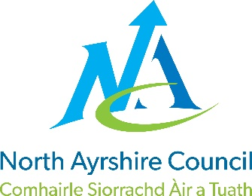

Please include the following documents with your application:
- A copy of relevant location plan(s)
- Evidence of public liability insurance
- Detailed technical specification, and installation details, of any proposed attachments from supplier.
- A copy of energy agreement if required (please see below for more details on this)
- Structural Inspection Certificate (if still valid)
- Wattage/consumption details
Please remember if you do not include these documents, it may cause delays or refusal of the application.
Energy Agreements
If your amenity requires an electricity supply, the loading/wattage details provided by the manufacturer or supplier and required timeframe should be passed to Scottish Power who can be contacted on 0800 074 0052 or www.scottishpower.co.uk. They will confirm your connection to their network, power consumption and cost/agreement. Once calculated, they will ask you to identify your preferred supplier (e.g. Scottish Power, Scottish Gas, N-Power etc). You will be required to enter an energy agreement with your supplier for the costs of the energy used.
Amenity Display Conditions
☐ Please tick this box to confirm that you agree to the Amenity Display Conditions, which can be accessed by clicking here or by visiting https://www.north-ayrshire.gov.uk/roads and selecting “Road Maintenance Permits and Services.”
Please email the completed form and all required documents to roadspermits@north-ayrshire.gov.uk or send by post to North Ayrshire Council, Roads Permits, 3rd Floor East, Cunninghame House, Irvine, KA12 8EE.
If you have any queries, please telephone our freephone call centre on 01294 310000.
This section to be completed by North Ayrshire Council staff processing this application.
Have all required details and documents been provided? | ☐ Yes ☐ No
Has this application been approved? | ☐ Yes ☐ No
Licence Number
Approved By
Approval Date
Any optional comments

