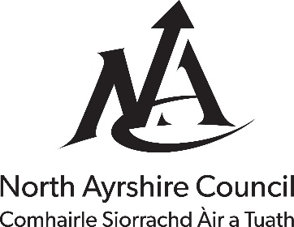
The Licensing (Scotland) Act 2005

Application for Planning Certificate under Section 50

Office use only
Reference number: Click or tap here to enter text.
Amount received: Click or tap here to enter text.
Payment type: Click or tap here to enter text.
Date received: Click or tap to enter a date.
- Name and Address of Applicant and Agent (if appropriate):
Click or tap here to enter text.
Daytime Telephone Number: Click or tap here to enter text.
Email Address: Click or tap here to enter text.
- Address of Premises: Click or tap here to enter text.
- Existing or approved use of premises for which a Licence is sought, for example Public House, Restaurant, etc.: Click or tap here to enter text.
- Provide the following information:
(i) Date and reference of Planning Permission: Click or tap here to enter text.
or Date and reference of Certificate of Lawful Use or Development: Click or tap here to enter text.
(ii) Plans of Premises including Location Plan: Click or tap here to enter text.
I/We hereby certify that the plans accompanying this application are an exact copy of the plans I/we intend to lodge with North Ayrshire Licensing Board.
Signature of Applicant/Agent: Click or tap here to enter text.
Date: Click or tap to enter a date.

Address to which application should be submitted together with 1 set of plans, a copy of the draft operating plan (if available) and a fee of £137.81:
North Ayrshire Council
Building Standards
Cunninghame House
Irvine
KA12 8EE
Email: economicgrowthsupport@north-ayrshire.gov.uk
Telephone: (01294) 324348

