THE CHILDREN (PERFORMANCES AND ACTIVITIES)
(SCOTLAND) REGULATIONS 2014

CHECKLIST FOR APPLICANTS

- Application form completed and signed*

- Application form completed and signed by the parent/guardian of the child*

- Copy of the contract – particulars of the performance in which the child is take part (including rehearsals and hours relating to age of child)*
- Copy of birth certificate of the child (or other satisfactory evidence of child’s age enclosed)*
- 2 identical unmounted prints of a photograph of the child taken within the preceding 6 months*
- Statement from child’s parent that the child is medically fit for the proposed activity*
- Copy of risk assessment of premises where child is performing*

- Letter from child’s school giving permission for absence (if time off school is required)* or head teacher’s signature on form
- Verified chaperone checklist and copy of PVG/Scheme of Membership Statement for chaperone*
- Details of the overnight accommodation where the child is staying if different from home address (if applicable)*
- Have suitable arrangements been made for transport of the child? (if applicable)

- Have suitable arrangements been made to educate the child (if applicable)

- Copy of PVG/ Scheme of Membership Statement for private teacher* (if applicable)
- Copy of private teacher’s registration with professional body* (if applicable)

Items 1-8 are required to process application (Item 9 if chaperone appointed) –
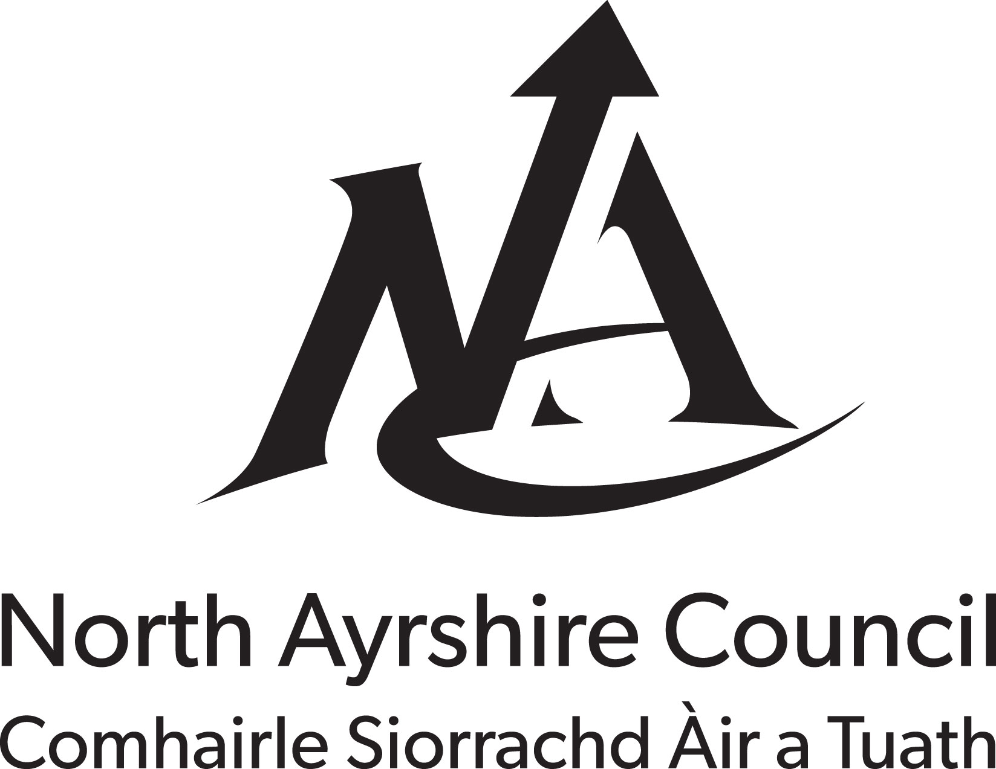
*check box to confirm that these documents are enclosed

CHAPERONES – CHECK LIST

Essential Criteria

Demonstrable experience of working with children and young people, including previous experience of acting as a chaperone to children and young people
2 Character References

Photo ID

Current membership of Protection of Vulnerable Groups scheme

Doctor’s confirmation that they are fit and well – as required

Details of any previous and/or current listing on another licensing authority’s administrative chaperone register
Face to face interview

Desirable Criteria

Awareness of the UNCRC and the Rights of the Child
www.unicef.org/crc/index_30160.html
Knowledge of the Common Core of Skills, Knowledge and Understanding and Values for the Children’s Workforce
Awareness of Getting it Right for Every Child (GIRFEC) –
www.gov.scot/Topics/People/Young-People/gettingitright
Awareness of the concept of Wellbeing and how to promote the wellbeing of children of varying ages

Check box to confirm these measures have been followed, verify and return with application form (licence can be refused if essential criteria not completed)

Verified by _________________ Date ______

