

CIVIC GOVERNMENT (SCOTLAND) ACT 1982

APPLICATION FOR A

LATE HOURS CATERING LICENCE

Completed application forms and enquiries to:

North Ayrshire Council, Licensing Office, Cunninghame House, Irvine KA12 8EE

Telephone 01294 324305

Email licensing@north-ayrshire.gov.uk

FOR OFFICE USE ONLY

Ref. No.

Date of Receipt

Fee Paid

Name of Applicant

Address of Premises

 | Consultation Requested | Consultation Received

Police Scotland

Environmental Health

Fire
MEETING DETAILS

Committee Meeting

Hearing

Granted/Refused

PLEASE READ ACCOMPANYING NOTES BEFORE COMPLETING APPLICATION

FOR INDIVIDUAL APPLICANTS ONLY (See Note 1)

1. Full Name
Address
Town
Post Code
Contact Telephone No.
Email address
Age, Date & Place of Birth | Aged: |  |  | D.O.B: |  |  |  | Place:
1.1 Do you intend to trade under your own name? | *Yes/No  *please cross out whichever does not apply
1.2 If “No” please give Trading Name
1.3 Will you carry out the Day to Day Management of the Business? | *Yes/No  *please cross out whichever does not apply
1.4 If “No” please give the following details of the person responsible for Day to Day Management:
Full Name
Address
Town
Post Code
Contact Telephone No.
Age, Date & Place of Birth | Aged: | D.O.B: |  |  |  | Place:
FOR APPLICATIONS BY COMPANIES/PARTNERSHIPS ETC. (See Note 2)

2. Company Name/Trading Name
Registered Office
Town
Post Code
Telephone No.
Company Registration No.
Date Registered
2.1 On an accompanying statement the following information is required before the application can be processed:  Full Name, Address, Date of Birth of all Partners or Company Directors, Company Secretary and Shareholders (only include Information for Shareholders for companies with five or fewer shareholders) | Accompanying Statement Attached  *Yes/No  *please cross out whichever does not apply
2.2 Details of the Person who will manage the premises:
Full Name
Address
Town
Post Code
Contact Telephone No.
Age, Date & Place of Birth | Aged: | D.O.B: |  |  |  | Place:

TO BE COMPLETED BY ALL APPLICANTS

3. Details of Premises from which you propose to trade: (See Note 3)
Address
Town
Post Code
Telephone No.
4. Please state the hours for each | Monday |  | 11.00 pm |  | To |  |  |  | am/pm
day of the week you wish a licence | Tuesday |  | 11.00 pm |  | To |  |  |  | am/pm
(See Note 4) | Wednesday |  | 11.00 pm |  | To |  |  |  | am/pm
 | Thursday |  | 11.00 pm |  | To |  |  |  | am/pm
 | Friday |  | 11.00 pm |  | To |  |  |  | am/pm
 | Saturday |  | 11.00 pm |  | To |  |  |  | am/pm
 | Sunday |  | 11.00 pm |  | To |  |  |  | am/pm

5. Please give details about the type of meals or refreshments you would be selling during the hours of the licence
6. Have you or any person named in this form ever held or currently hold a Late Hours Catering Licence | *Yes/No  *please cross out whichever does not apply

If “Yes” then:
6.1 Which Authority (Council) granted it?

6.2 When was it granted?

6.3 When does it expire?
7. Have you or any person named in this form ever applied for and been refused a licence for Late Hours Catering | *Yes/No  *please cross out whichever does not apply

If “Yes” then:

7.1 Which Authority (Council) refused it?

7.2 When?

8. Previous Convictions  (See Note 5)  Have you or anyone named in this form (including any Limited Company) ever been convicted of any crime or offence including offences under Byelaws OR been a Partner in a Partnership or Director, Secretary or Controller of a Company or an Officer of any other organisation which has been convicted of an offence? | *Yes/No  *please cross out whichever does not apply

All persons named on application form must complete the attached Schedule of Convictions.

DECLARATION TO BE COMPLETED BY ALL APPLICANTS

Any person who, in or in connection with, the making of this application makes any statement, including statements concerning other parties, which he/she knows to be false or recklessly makes any statement which is false in a material particular shall be guilty of an offence and liable, on summary conviction, to a fine not exceeding £2,500.

(a) I/we declare that I/we shall, for a period of 21 days commencing with the date hereof, display at or near the premises so that it can conveniently be read by the public, a notice complying with the requirements of Paragraph 2(3) of Schedule 1 to the Act and I/we shall thereafter produce a Certificate of Compliance with Paragraph 2(2); or

(b) I/we declare that I am/we are unable to display a notice of this application at or near the premises because I/we do not have the rights of access which would enable me/us to do so, but I/we have taken the following steps to acquire those rights namely:-

but have been unable to do so.

I/we declare that the particulars given by me/us on this form are correct to the best of my/our knowledge and belief.

Signature of Applicant_____________________________ Date ____________________

North Ayrshire Council, Licensing Office, Cunninghame House, Irvine KA12 8EE (Tel: 01294 324305)
www.north-ayrshire.gov.uk

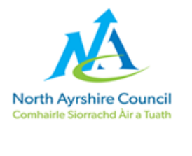

Personal Declaration Form 1
(All licences except Drivers and Landlords)

Use this form if the Application is about anything except:
- Taxi Driver's Licence
- Private Hire Car Driver's Licence
- Landlord Registration

If the Application is about any of these, use Form 2 instead. Use Form 1 if the Application is about a vehicle - a "Taxi Licence" or "Private Hire Car Licence" (sometimes called "Operator's Licences").

Name

Address

(including postcode)
Date of Birth

Place of Birth

We need to know about the criminal record of anyone applying for a Licence, or a Joint Holder, or part of a licensed business, or managing a licensed business, so they all need to fill in a Personal Declaration Form, but before you fill in the form you should read this note about 'Rehabilitation of Offenders'.

'Rehabilitation of Offenders'

This is the rule is that after a period of time some convictions (not all) are 'spent' or 'protected'. This means:

- these convictions do not have to be declared to the Council on this form, and

- the Council will probably not look at these convictions.

However, the rules have a lot of exceptions and are complicated. The main exception is that there are different rules for:

1. Drivers of Taxis or Private Hire Cars, and Landlords

2. Everyone else (this includes Operators of Taxis or Private Hire Cars)

Because there are different rules, the Council has different Declaration Forms. You should use the Form which applies to the Licence you want.

There is a summary of the rules below.

How to fill in this form

Apart from the 'Rehabilitation of Offenders' rules, you must tell us about everything.

Please complete this form, and sign it.

Apart from the 'Rehabilitation of Offenders' rules, do you have any of these penalties?

- Convictions
- Fixed Penalties
- 'Fiscal Fines'
- Immigration Penalties

I have none of these (write 'none')
I have listed the penalties below

Date | Court | Crime/Offence | Disposal

Your Licence Application, and this form, will be sent to the Police. Even if a conviction is 'Spent' or 'Protected' - so that you don't have to disclose it - the Police can still tell the Licensing Committee about it, and the Committee can decide whether or not justice cannot be done without looking at that conviction.

Notices
1. The information you give us in this form and in the Licence Application will be kept by us for as long the Licence is in force (including any time where it is temporarily suspended).
2. We follow National Fraud Initiative guidelines to protect against fraud. For more information see:
https://www.north-ayrshire.gov.uk/council/access-to-information/national-fraud-initiative.aspx
3. Data Protection Fair Processing Notice - We will use any information given to us by or about anyone mentioned in this Application when it is necessary for the operation of the Licensing system authorised by Law. For more information, see the Council's "Fair Processing Notice".

I certify that this information is true and complete, and I understand that I may be prosecuted and my Licence refused, revoked or suspended if it is not.

Name in BLOCK CAPITALS
Signed
Date

Summary of 'Spent Conviction' Rules

This is only a summary. The legislation here is particularly complicated and we cannot give detailed advice tailored for your particular circumstances. You should take independent legal advice.

The legislation includes

1. Rehabilitation of Offenders Act 1974.

2. The Rehabilitation of Offenders Act 1974 (Exclusions and Exceptions) (Scotland) Order 2013, No. 50.

3. The Rehabilitation of Offenders Act 1974 (Exclusions and Exceptions) (Scotland) Amendment Order 2015, No. 329.

4. The Rehabilitation of Offenders Act 1974 (Exclusions and Exceptions) (Scotland) Amendment Order 2016 No. 91.

5. The Rehabilitation of Offenders Act 1974 (Exclusions and Exceptions) (Scotland) Amendment (No. 2) Order 2016 No. 147.

6. The Rehabilitation of Offenders Act 1974 (Exclusions and Exceptions) (Scotland) Amendment Order 2018 No. 51.

All the legislation is freely available on the Government website www.legislation.gov.uk

The main 'Spent Conviction' rules setting the 'Rehabilitation Period' (RP) are in the Section 5 of the 1974 Act (Tables A and B). This table summarises them - references in [...] are to section numbers. The rules also include Schedule A1 and Schedule B1 in the 2013, 2015 and 2016 Orders.

Sentence | RP
Absolute Discharge | 6 months [5(3)(a)] (regardless of age of offender; regardless of Court procedure: [4(1)] )
Road Traffic Act  Endorsement & Disqualification | 5 years - [5(2)], final entry in Table A (halved if under 18 at conviction)
Admonition | 5 years - [5(2)], final entry in Table A (halved if under 18 at conviction)
Probation | 5 years if aged 18 or over on conviction, (but see [5(4A)] as it may be up to 2.5 years if under age 18)
Fine | 5 years - [5(2)] Table A (halved if under 18 at conviction)
Good Behaviour  Deferred Sentence  (typically 6 or 12 months) | [5(4)] RP is the longer of:  (a) one year  (b) the end of the deferral.
Hospital Order under Mental Health (Scotland) Act | [5(7)] RP is the longer of  (a) 5 years  (b) two years after end of Order
Children's Hearing
This only applies to cases about crimes. Other reasons for a child being on a Supervision Requirement (for example, being the victim of neglect) do not count as 'convictions'
Discharge | 6 months [5(3)(b)]
Supervision Requirement | [5(5)(f)] RP is the longer of  (a) one year from 'conviction' or  (b) the period until the S/R ends:
Youth Detention:
up to 6 months | 3 years - [5(2)] Table B
over 6 but under 30 months | 5 years - [5(2)] Table B
Borstal (any period) | 7 years - [5(2)] Table B
over 30 months (or life) | never becomes 'spent' - [5(1)]
Adult Imprisonment:
up to 6 months | 7 years - [5(2)] Table A (halved if under 18 at conviction)
over 6 but under 30 months | 10 years - [5(2)] Table A (halved if under 18 at conviction)
over 30 months (or life) | never becomes 'spent' - [5(1)] (regardless of age of offender)

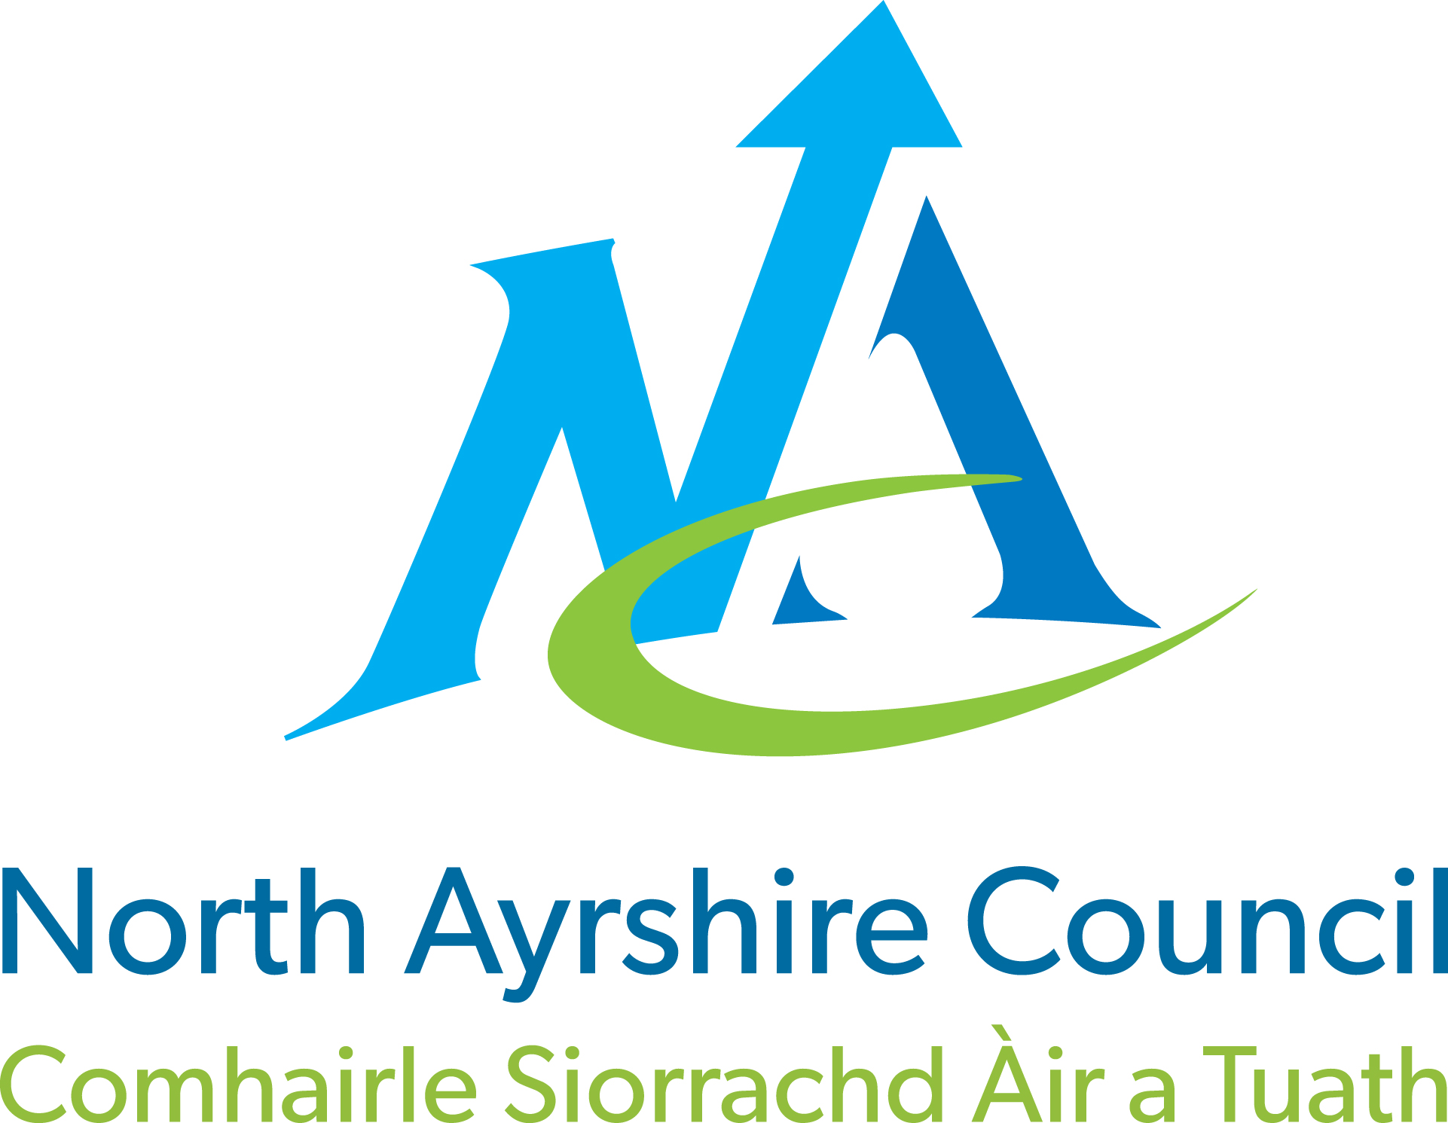

CIVIC GOVERNMENT (SCOTLAND) ACT 1982

LATE HOURS CATERING LICENCE

NOTICE FOR DISPLAY ON PREMISES

NOTICE IS HEREBY GIVEN that application has been made on _______________ to North Ayrshire
(date of application)
Council for a licence for Late Hours Catering in respect of the premises at

_______________________________________________________________________________

_______________________________________________________________________________

This application has been made by

*NAME /COMPANY NAME/PARTNERSHIP ___________________________________________

*ADDRESS/REGISTERED OFFICE ___________________________________________

___________________________________________

DAY TO DAY MANAGER (if appropriate) ___________________________________________

___________________________________________
*delete as applicable

Any objections and representations in relation to the application may be made to the Licensing Department, North Ayrshire Council, Cunninghame House, Irvine KA12 8EE, generally within 21 days of the date noted above. Objections and representations must contain information which is required by the Act namely:-

- Any objection or representation relating to an application for the grant or renewal of a Licence shall be considered by the licensing authority if, but only if, the objection or representation is:-
- in writing
- specifies the grounds of the objection or, as the case may be, the nature of the representation
- specifies the name and address of the person making the objection or representation
- is signed by him or on his behalf and
- was made to the licensing authority within 21 days of which is the later date, or as the case may be , latest of the following dates:-
- where public notice of the application was given in a newspaper, the date when first given
- where North Ayrshire Council has ordered the applicant to display the Notice again from a specified date, that date
- in any other case, the date when the application was made to the licensing authority

- Notwithstanding the dates set out in paragraph 1 (e) above, it shall be competent for a licensing authority to consider an objection or representation received by them before they take a final decision on the application to which it relates if they are satisfied that there is sufficient reason why it was not made in the time required.

- An objection or representation shall be made for the purposes of paragraph 1 above if it is delivered by hand within the time specified to the licensing authority or posted (by registered or recorded delivery post) so that in the normal course of post it might be expected to be delivered to them within that time.

CIVIC GOVERNMENT (SCOTLAND) ACT 1982

LATE HOURS CATERING LICENCE

CERTIFICATE OF COMPLIANCE

I/We

(Name and Address as specified in application)

applicant(s) for a Late Hours Catering Licence, hereby certify that a Notice has been posted at or near the premises at

(premises as specified in application)

FROM

TO

containing such information as is required by Paragraph 2(3) of Schedule 1 to the above Act.

* Where the said Notice was removed, obscured or defaced during the above mentioned period I/we took reasonable steps for its protection and replacement as follows (give details and circumstances including the dates on which replacement notices were displayed)

Date ______________________ Signature _________________________________

*Delete if not applicable

INFORMATION ON LATE HOURS CATERING LICENCES

The purpose of these notes is to give some help to anyone applying for a Late Hours Catering Licence. The notes give information about the need for a licence and the various forms which make up the application. After you have read these notes, if you need any further explanation, please contact the licensing office. (See front of application for contact address and telephone number). We are only able to give advice on the law and how the applications are dealt with and cannot give you advice about what you need for your own business. As the licence affects how your business can operate we recommend that you go over this with your own solicitor or representative.

The law which deals with this is the Civic Government (Scotland) Act 1982 and in particular Section 42 and Schedule 1 of the Act. The notes give information about this but you or your solicitor may not agree with our interpretation of what the Act says and so you may want to check this information out yourself.

What is the licence for?

You must have a “Late Hours Catering Licence” for premises where “meals or refreshments” are for sale to the public to eat either on or off the premises between the hours of 11p.m. and 5a.m. the next morning. Trading during those hours without a licence is a criminal offence and you can be prosecuted for not having a licence. The maximum fine which can be imposed for any one offence is £2,500. You do not need a licence if the premises are licensed for public entertainment or to sell alcohol during those hours. The Act does not give a definition of the word “refreshments” and that would be a matter for you to discuss with your solicitor before you lodge the application.

Notice of application

The use of premises during those hours may have an effect on other nearby properties. To make sure that people are aware of the application you must display a notice on the property for 21 days from when you submit the completed application form to the Licensing Office. Included with the application form is a form for display which you may wish to use. As you can see this notice must contain certain information:-

- That an application has been made for a licence.

- Particulars about the type of licence applied for including the times applied for, details about the applicant, the day to day manager or the company involved.

- The address of the property.

- The procedure for making an objection or representation about the application.

The full details about these procedures are set out in Paragraphs 2 and 3 of Schedule 1 of the Civic Government (Scotland) Act 1982.

After you have completed the form you must display the notice at or near the premises for which the application is being made. There will be checks made to ensure that a notice is being displayed where it can be read by the public. You may put it in the window of the property but if, for example, you use roller shutters over the windows this means that the notice cannot be read after the shop has closed and so you will not be displaying the notice as the Act requires. If the Notice is removed, defaced or obscured you must replace it.

Certificate of Compliance

A Certificate of Compliance is also included with the application. This is the form which you must complete and send in to the Licensing Office as soon as possible after the 21 days notice. This form cannot be submitted with the application form as we would be concerned that the correct information had not been on the Notice.. If you do not return the Certificate of Compliance then we cannot deal with your application. As you can see from the Certificate you need to give the dates when the Notice was displayed and whether you had to replace it.

What is involved in processing the application?

The Licensing Office has to carry out certain investigations into the application and it is sent to Strathclyde Police and the Fire Authority. It also goes to other departments of the Council for example Environmental Health to comment on the property. If the application is to renew an existing licence and there are no adverse comments about it then it does not need to go to the Licensing Committee to be approved. If the application is for premises which have never been licensed before or the person applying is new to the premises or if objections/comments have been received then it does go to Committee.

In any case where the Licensing Office has received objections or adverse comments from any of the consultees then the application is considered at a Hearing which you will be invited to attend and for which you will be told of the objections or comments so that you can have an opportunity to reply to those. You will get at least seven days notice of any Hearing.

Planning Permission

The application form does not ask if you have planning permission for the use of the premises. It is assumed that any establishment of the type applying for a licence will have such permission. There are some properties which have planning permission but have a condition which prevents them trading after a certain time. You are strongly advised to check your planning permission to make sure that this does not apply to you. If you fail to check this and it is subsequently found out that you do not have planning permission the licence will not alter the situation. You must have both Planning permission and a licence to operate during these hours.

Cost of Application

The Act places a duty on the Licensing Authority to meet the cost of operating the licensing system from the fees paid. The fee set for this type of licence must be paid when the application is lodged. It will not be dealt with until the fee is paid. It is stressed that the fee is for the processing of the application and not for the grant of a licence. Payment of the fee does not guarantee that a licence will be granted. If the application is for a new licence you are not permitted to start trading during the hours applied for until your licence has been granted.

Please read these notes before completing the application form

Note 1

If you are the sole owner of the business for which you are applying for a licence you should complete the questions in Section1. This includes information about the trading name of the company. There can be cases where the person applying will not be running the business all the time and you may wish to put in a “day to day” manager. The Licensing Authority needs full information about this person and this should be given in question 1(e) and if it does not apply to your application please write “none” against this.

Note 2

If the application is from a company or a partnership then Section 2 must be completed. Full details are required about the officers of the Company or of the partners and in this Section it is essential to give the details of the person who will be managing the premises for the company or the partnership.

Note 3

Please provide details of the property to be licensed. Even if the take-away service is operated from only part of your premises and restaurant closes down before 11 o’clock it is still necessary to provide information about the entire property.

Note 4

A Late Hours Catering Licence does not need to be to the same time each day and it does not need to be for every day of the week. Please state for each day the hour you wish to trade until the next morning. If you do not put a time beside a particular day, the application will not be considered for that day or days.

Note 5

The Licensing Authority needs to be sure that the licenceholder is a proper person to hold a licence. Every person named in the licence will be checked and so it is essential that every person named in the application completes this question. A Form is provided for this purpose. It is important to complete this accurately as it is an offence to fail to disclose a conviction and you can be fined for this as well as the possible loss of any licence which was granted when your conviction was not declared.

If you need any more information about your application please contact the Licensing Office, North Ayrshire Council, Cunninghame House, Irvine KA12 8EE telephone 01294 324305. This is also the address to which you should send the completed application and the fee.

