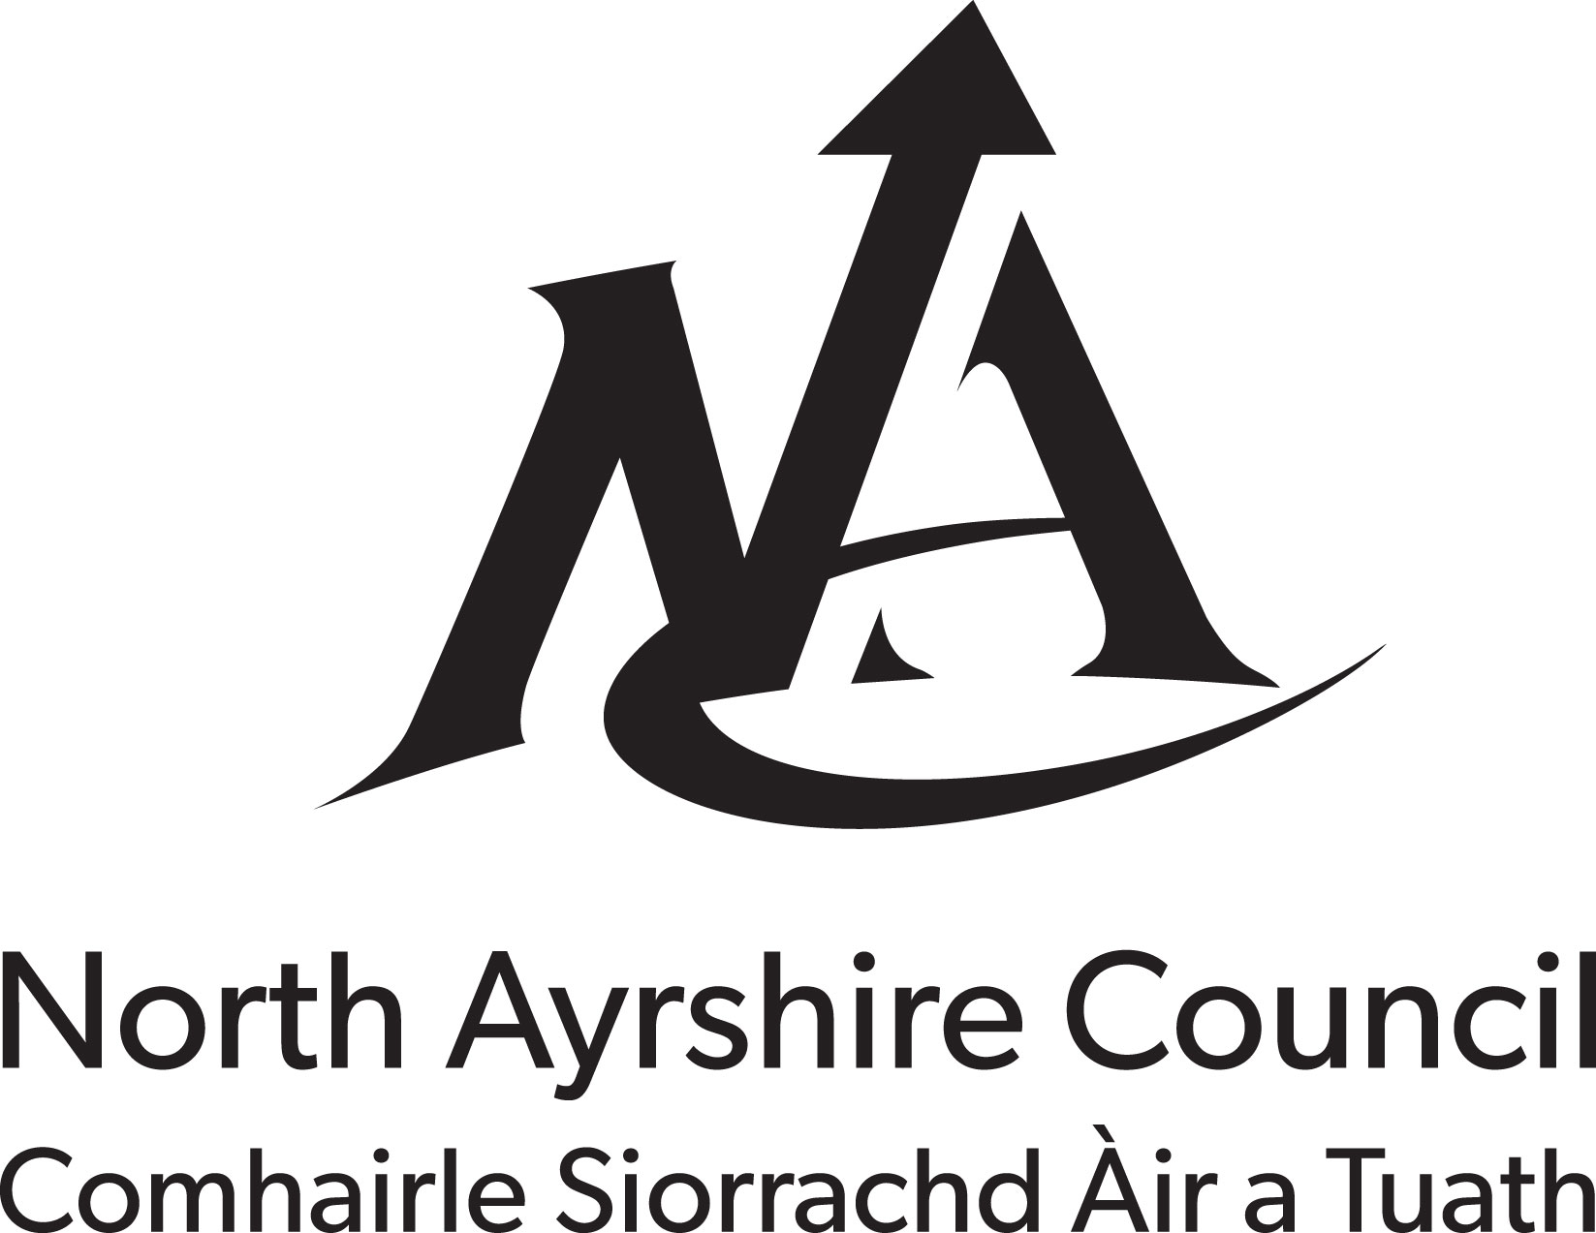

FOOD BUSINESS REGISTRATION
FOR CHILDMINDERS OPERATING FROM DOMESTIC PREMISES
(Regulation (EC) No. 852/2004 on the Hygiene of Foodstuffs, Article 6(2)) INSTRUCTIONS FOR COMPLETION OF THE FORM
Consider if your food activities are limited to those included in SECTION A if they are you are not required to register as a food business with your local authority Please do nothing more.
Childminders with more extensive food activities should complete SECTION B, sign the bottom of the form and then send it to your North Ayrshire Council, Environmental Health Section (contact details below) .
SECTION A IF YOUR FOOD ACTIVITIES ARE LIMITED TO THIS LIST - YOU DO NOT NEED TO REGISTER AS A FOOD BUSINESS, DO NOT COMPLETE THIS FORM OR SEND IT TO YOUR LOCAL AUTHORITY
- Provision of mains drinking water.
- Provision of crockery and cutlery for use by children to eat their own packed lunches.
- Provision of chilled storage for packed lunches that belong to the children.
- Occasional assistance to children with cutting up their own food in response to individual need rather than as an established service.
- Occasional provision of food that is not part of the normal service (e.g. a cake to celebrate a child's birthday or provision of food where a parent/guardian has been delayed).
- Operating in the child's own home and serving food that belongs to the child's parent/guardian e.g. nannies and home child carers.

SECTION B TO BE COMPLETED BY CHILDMINDERS WITH MORE EXTENSIVE FOOD ACTIVITIES
Name of the food business operator (owner)
Address of the food business
Post code
Telephone number
E-mail address (if applicable)
How many children do you look after? |  |  | Average per day Maximum at one time
What is the age range of the children?
Which type of water supply do you have? |  |  | MAINS PRIVATE
Do you provide drinks and snacks only? |  |  |  | YES | NO
Additional information
Do you prepare or provide meals? |  |  |  | YES | NO
Have you received food hygiene training? |  |  |  | YES | NO
Please circle any of the following foods you either prepare or provide:  - Formula Milk  - Sandwiches  - Dairy Products  - Salads |  | - Cooked Meats  - Raw Meat/poultry  - Eggs  Other foods (please specify)
PLEASE NOW SIGN THE BOTTOM OF THIS FORM AND SEND IT TO:- ENVIRONMENTAL HEALTH SECTION, NORTH AYRSHIRE COUNCIL, CUNNINGHAME HOUSE, IRVINE, AYRSHIRE, KA12 8EE

Signature of the food business operator (Owner) Date

Name (BLOCK CAPITALS)

PRIVACY NOTICE

What we need

North Ayrshire Council and Food Standards Scotland (FSS) are Joint Data Controllers of the personal information you provide to us on this form. The information we collect about you includes name, postal address, email address and telephone number.

Why we need it

- As Joint Data Controllers, we need to collect this information for the purposes of Food Law Enforcement.
- Regulation (EC) No 882/2004 on Official Controls performed to ensure the verification of compliance with Food Law, requires that North Ayrshire Council and FSS coordinate effectively in the field of Environmental and Health protection, carrying out their activities with a high level of transparency, making relevant information available to the public as soon as possible.
- Each Local Authority is required to maintain an up to date list of registered Food Business Establishments in its area and divulge this information for the purposes of ensuring public health and the effective enforcement of Food Law.
- The Food (Scotland) Act 2015, enables FSS to set performance standards, report on enforcement action by others and require relevant information from North Ayrshire Council
- The Official Feed and Food Controls (Scotland) Regulations 2009, allows the exchange and provision of information by FSS and North Ayrshire Council for the execution and enforcement of relevant Food Law, and makes provision for North Ayrshire Council to provide FSS with Food Business information.
- North Ayrshire Council and FSS are required to fulfil the statutory obligations required by Article 113 of Regulation (EC) No 2017/625, which places a requirement on Local Authorities and FSS to provide the information specified in that Article and to report to the European Commission.
- FSS maintains a national database that can be accessed by both Food Standards Scotland and the Local Authority to which the information pertains. The reporting toolset allows information to be strategically analysed, allowing both organisations to adhere to the principles of the Scottish Regulators’ Strategic Code of Practice.
- We will only collect the data that we need as required by the above regulations and legislations, and not collect any personal information from you that we do not need.

What we do with it
The information on this form will be retained by North Ayrshire Council and FSS for the duration of your business registration. Additionally if your business closes, or your registration details are otherwise amended then this information will continue to be retained for a maximum of six years following notification of the closure or the amendment of your registration details.

The information collected on your business relating to Food Law enforcement activity will be retained by North Ayrshire Council for a maximum of six years for Freedom of Information purposes. Food Standards Scotland collects food business information from North Ayrshire Council on a regular basis for the purposes of Food Law Enforcement. The same information will be retained by FSS for a maximum of 6 years, also for Freedom of Information purposes and the monitoring of enforcement action by Local Authorities.

FSS have put in place appropriate and adequate technical and organisational measures to protect your personal information. FSS data is located within the European Union, on cloud based services procured through the government framework agreements, and assessed against the national cyber security centre cloud security principles.

Details of how North Ayrshire Council will handle personal data and how to contact our Data Protection Officer can be found in our corporate privacy policy at https://www.north-ayrshire.gov.uk/privacy-policy.aspx

We want to assure you that no third parties have access to your personal information unless the Law allows them to do so.

What we may also be required to do with it

The information may be shared with other Regulators in line with the principles of the Scottish Regulators Strategic Code of Practice for compliance and risk mitigation purposes. This is limited to circumstances where the law allows such sharing of information by regulators with common interests or activities and will not include personal information.

What are your rights?

You have a right to see the information we hold on you by making a request in writing to the email addresses below. If at any point you believe the information we process on you is incorrect you can request to have it corrected. If you wish to raise a complaint on how we have handled your information, you can contact our Data Protection Officers who will investigate the matter. If you are not satisfied with our response or believe we are not processing your information in accordance with the law you can complain to the Information Commissioner’s Office (ICO).

If you need any further information please contact North Ayrshire Council's Data Protection Officer at dataprotectionofficer@north-ayrshire.gov.uk. Or Food Standards Scotland’s Data Protection Officer at: dataprotection@fss.scot.

