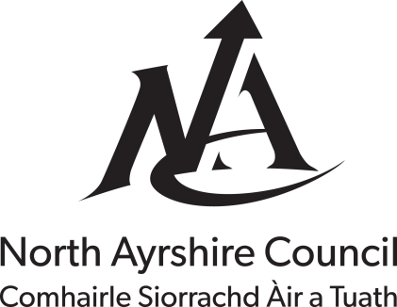

Explanatory Leaflet for Council Tax Exemption for Bankruptcy.

Under Council Tax legislation exemption can be awarded for an unoccupied property where Council Tax liability is due by a Permanent Trustee, appointed in terms of the Bankruptcy (Scotland) Act 1985.

In order to award exemption under this category documentary evidence must be supplied proving the status of the property. This can be in the form of a letter from the trustee confirming that the person liable to pay the Council Tax is subject to bankruptcy.

Review of the Exemption

The exemption will continue for the specified period providing the qualifying criteria are being met. However, North Ayrshire Council will conduct a review of the circumstances by contacting you by telephone or email. If at any time you believe the reduction no longer applies then you must contact the Council immediately.

Do you need Help with this Form?

If you have any questions regarding this application please telephone 01294 310000 from 08.30am to 05.30pm Monday to Friday. You can also visit the public enquiry desk at Bridgegate House, Irvine from 09.00am to 04.45pm Monday to Thursday and 09.00am to 04.30pm on a Friday or use the Contact Us facility on the Council's web site.

What do you think?

We value the opinions of our customers. This form has been designed to be in plain, jargon free language however, if you find any of the sections difficult to understand or complete please let us know by completing the suggestion box at the end of the form.

Council Tax Reference No.
> Please supply the following telephone numbers in case we need to contact you regarding this application.
Daytime Telephone No.

Evening Telephone No

Email address

Mobile Telephone No. |  | Please indicate if you would like to receive contact by text regarding your application.  YES NO (please tick)

>Section 1: To be completed by the Permanent Trustee
What is the full name of the person subject to bankruptcy?

What is the full postal address including postcode of the property owned by the person now subject to bankruptcy?

What is their current address?
(This should the be the full address including postcode.)

Please confirm the full name and address of the Permanent Trustee appointed in terms of the Bankruptcy.

What date did the property become unoccupied?
Please confirm the date the person became bankrupt?
Company Stamp (below) If no stamp is available please attach a compliment slip. |  | Signed:…………… …………………….  Position:…………………………………  Date:……………………………………..

Declaration
I declare that the information I have given in this form is correct and complete and I agree to notify you immediately of any changes that might affect my Council Tax.

I understand that the deliberate provision of false information in order to achieve financial gain is a criminal offence and you may check the information with other sources as allowed by the law.

I understand that any information I have provided will be used in the administration of my Council Tax account. You may give information to other parties if the law allows this.
Signature of liable person

Date

What do you think?

Was the form easy to complete? | Yes No  If you answered No please give details:
Was the form easy to understand? | Yes No  If you answered No please give details:
Was there any information not included on the form which you would like to see included?
Do you have any suggestions on how the form could be improved?

