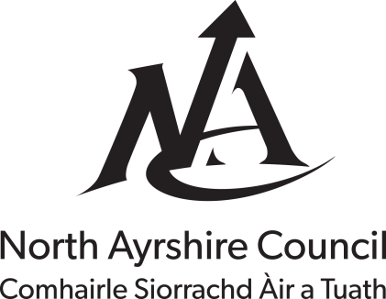

Explanatory Leaflet for Council Tax Discount for Someone in receipt of Child Benefits and over the age of 18.

When counting the number of residents in a property persons over 18 years of age continuing in full-time education are disregarded when someone receives Child Benefit for them.

To apply for discount please provide the information requested overleaf, sign the declaration and return the form to the address shown below together with evidence that Child Benefit is being paid.

If you qualify for a discount we will send you a replacement Council Tax bill showing the reduced sum due. If the claim is unsuccessful or we require further information we will contact you.

Review of the Discount
The discount will continue until Child Benefit is no longer being paid. However, North Ayrshire Council will conduct a review of the circumstances by contacting you. If at any time you believe the reduction no longer applies then you must contact the Council immediately.

Do you need Help with this Form?

If you have any questions regarding this application please telephone 01294 310000 from 08.30am to 05.30pm Monday to Friday. You can also visit the public enquiry desk at Bridgegate House, Irvine from 09.00am to 04.45pm Monday to Thursday and 09.00am to 04.30pm on a Friday or use the Contact Us facility on the Council's web site.

What do you think?
We value the opinions of our customers. This form has been designed to be in plain, jargon free language however, if you find any of the sections difficult to understand or complete please let us know by completing the suggestion box at the end of the form.

Council Tax Reference No.

- Please supply the following information in case we need to contact you regarding this application.

Daytime Telephone No.

Evening Telephone No.

E-Mail Address

- To be completed by the person liable for Council Tax

What is your full name?

What is the full postal address including the postcode of the property?

What is your full postal address including the postcode of your

correspondence address?
(if different from above)

What is the full name of the person
Child Benefit is paid for?

What is the expected school leaving date?

Please indicate the number of persons 18 years of age or over usually resident in the house including the person Child Benefit is paid for?

Documentary Evidence

Please attach in support of this application documentary evidence of Child Benefit payment.

- Confirmation of credit transfer payments to bank or building society

Declaration
I declare that the information I have given in this form is correct and complete and I agree to notify you immediately of any changes that might affect my council tax.

I understand that the deliberate provision of false information in order to achieve financial gain is a Criminal Offence and you may check the information with other sources as allowed by the law.

I understand that any information I have provided will be used in the administration of my council tax account. You may give information to other parties if the law allows this

Signature of liable person

Date

What do you think?

Was the form easy to complete? | Yes No  If you answered No please give details:
Was the form easy to understand? | Yes No  If you answered No please give details:
Was there any information not included on the form which you would like to see included?
Do you have any suggestions on how the form could be improved?

